SOP: QC Process - Agent Files, QC Form, Correction and Rework
Module | QC Process - Agent Files, QC Form, Correction and Rework
Who uses it | QA and Assistant Team Leader (checks files); Agent (corrects / reworks); Managers and Admin (view results)
Version | 1.0
Issued | 21 Oct 2026
Screenshots are taken from the HRMS test copy. Names, dates and numbers are examples only.

1. Purpose
This SOP explains the full quality-check cycle in the HRMS: how QA picks an agent file, checks the sample on the QC form, marks errors, submits the result, and how Correction and Rework files come back from the agent and are reviewed again until the file is closed.

2. Who does what
Role | What they do in this process
QA | Checks agent files on the QC form, submits Regular / Correction / Rework, reviews corrected and reworked files, and closes them.
Agent | Sees the QC result and errors, downloads the marked file, and uploads the corrected or reworked file.
Project Manager, Assistant Manager, Admin | Follow results in QC Report Overview (see SOP - Manager - QC Report Overview).

3. Key terms
Term | Meaning
Sample | The rows QA checks. Number of rows = task QC % x records in the file, rounded up (10% if the task has no QC %).
QC Code | The unique code column in the agent file (for example 13-10-2026/Altrum/SS/34). Always refer to the QC Code, not the Excel row number.
Category / Error | Each project category has an error list (AFD). A category (for example Formatting) holds errors (for example Spacing/Extra Spacing, -10 points).
Regular | Score 100%. The file passes and is closed.
Correction | Score 98% to 99.99%. The agent fixes the marked sample rows and uploads the file again.
Rework | Score below 98%. The agent reworks the whole file and uploads it again.
Attempt | Correction #1, Rework #2, and so on: how many times the file has gone back to the agent.

4. Screen guide - Agent Files & QC Report
Open Agent Files & QC Report from the top menu. It has three tabs: Agent's Tracker File (new files to check), Agent's Rework & Correction File (files the agent sent back) and QC Report (QC you have done).
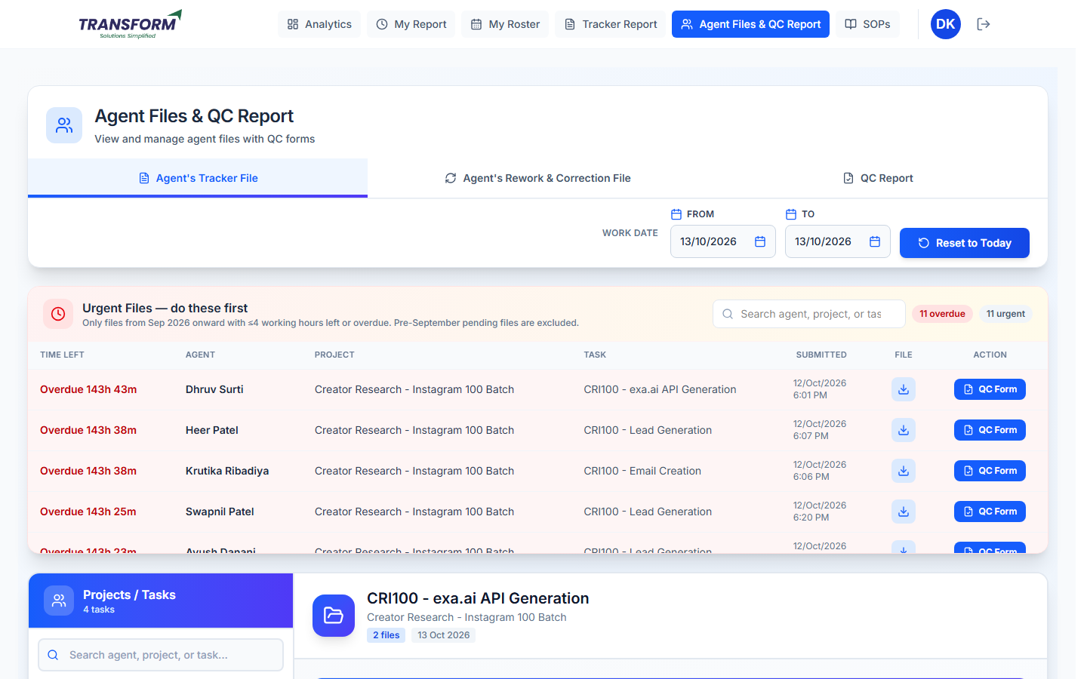
Figure 1: Agent Files & QC Report - Agent's Tracker File tab

4.1 Work Date filter
From / To filter files by the agent's work date. Reset to Today goes back to today. Night-shift files added after midnight carry the previous date.

4.2 Urgent Files - do these first
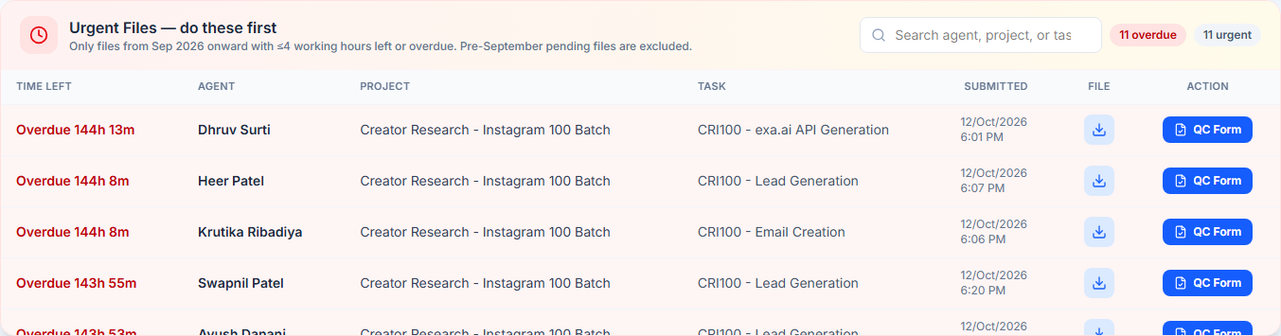
Figure 2: Urgent Files list
- Shows files from September 2026 onward that are overdue or have 4 working hours or less left.
- Time left is red when overdue and amber when less than 4 hours remain.
- The red and grey badges show how many files are overdue and urgent. Search filters by agent, project or task. 'View all N urgent files' shows the full list.
- Click a row to open that task below, the download icon to get the agent's file, or QC Form to start QC.

4.3 Projects / Tasks and the file list
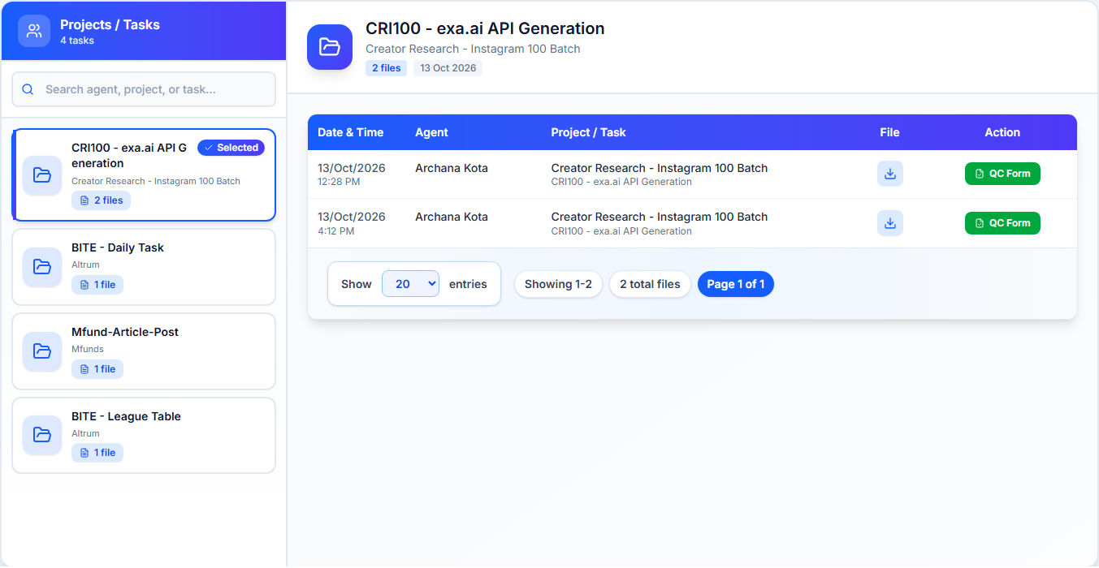
Figure 3: Projects / Tasks list and the files of the selected task
- Left: every project/task that has files for the dates, with the number of files. Use the search box to find an agent, project or task.
- Right: the files of the selected task - Date & Time, Agent, Project / Task, File (download) and QC Form.
- Use 'Show N entries' and the page buttons when there are many files.

5. Procedure - Check a file on the QC Form
1. Click QC Form on the file. The form opens with the sample rows. Check the header: agent name, file name, Click to Download (full agent file), submission date and time, project, task and any 'Project SOP' links.
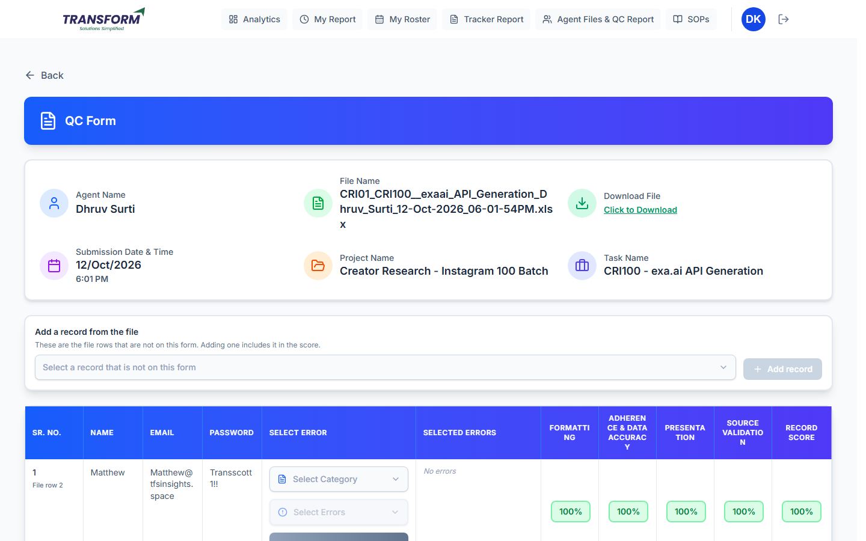
Figure 4: QC Form header and the first sample row
2. In the table each row shows Sr. No., the File row number, the QC code, the task's important columns, Select Error, Selected Errors, one score column per category and the Record Score.
3. To mark an error on a row: open Select Category and pick the category, open Select Errors and tick one or more errors (each shows its points; Select All and Search are available).
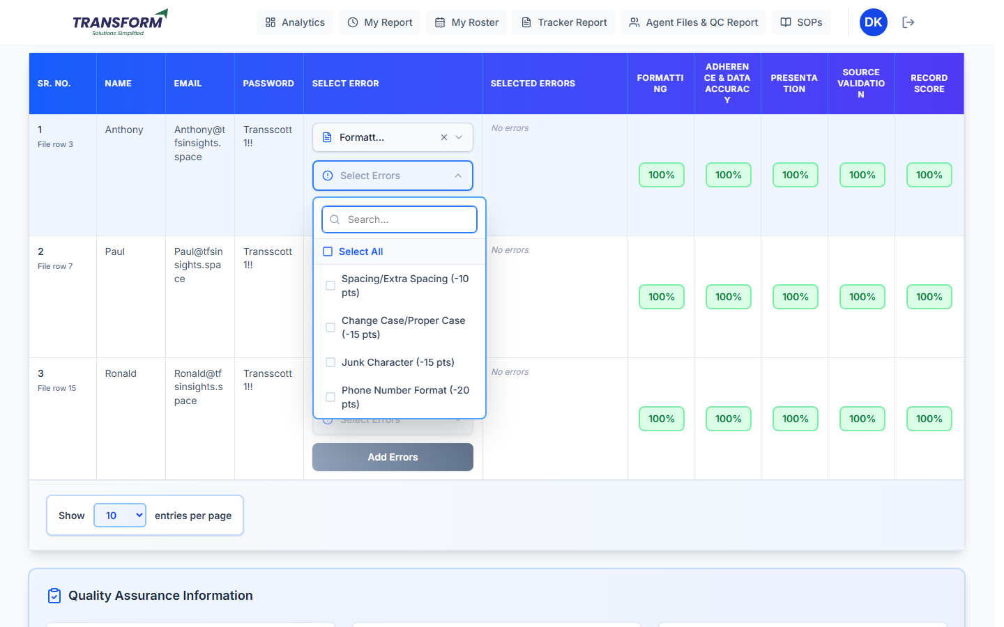
Figure 5: Choosing the category and the errors for a row
4. Click Add (n) Error(s). The error appears in Selected Errors and the scores update at once. Click x on an error to remove it. Repeat for other categories on the same row if needed.
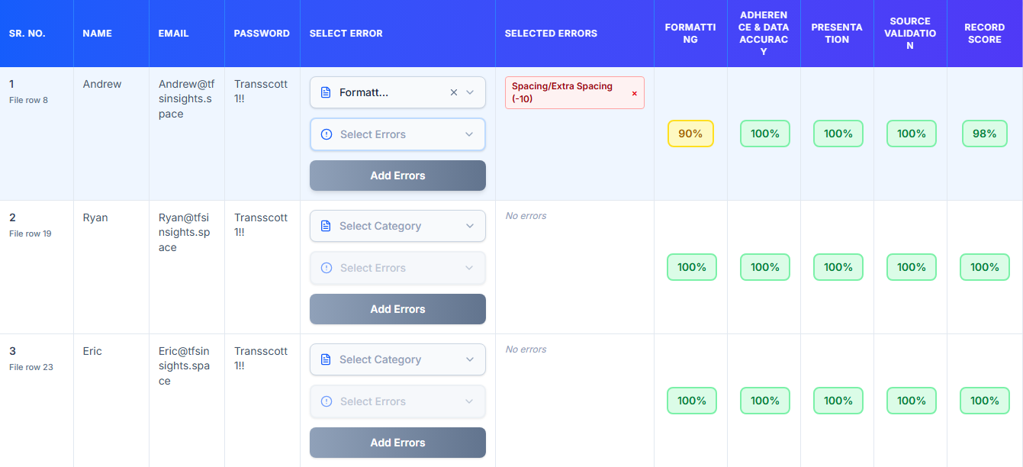
Figure 6: Error added - Formatting 90%, record 98%
5. To check a row that is not in the sample: open 'Add a record from the file', choose the row (it shows the QC code, or the row number and first values) and click Add record. The row is added at the end with an 'Added' badge and is included in the score and the saved QC file.
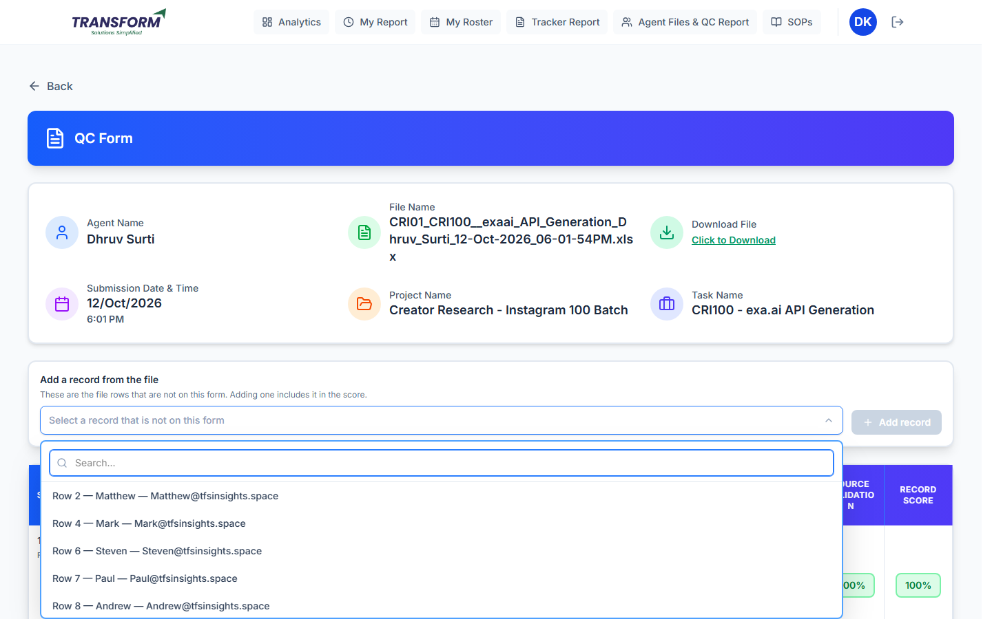
Figure 7: Rows of the file that are not on the form
6. Scroll down to Quality Assurance Information: QA name, Final QC Score, Status, Record Count in File, Data Generated for QC (includes added rows), Total Errors Marked and the Error Breakdown.
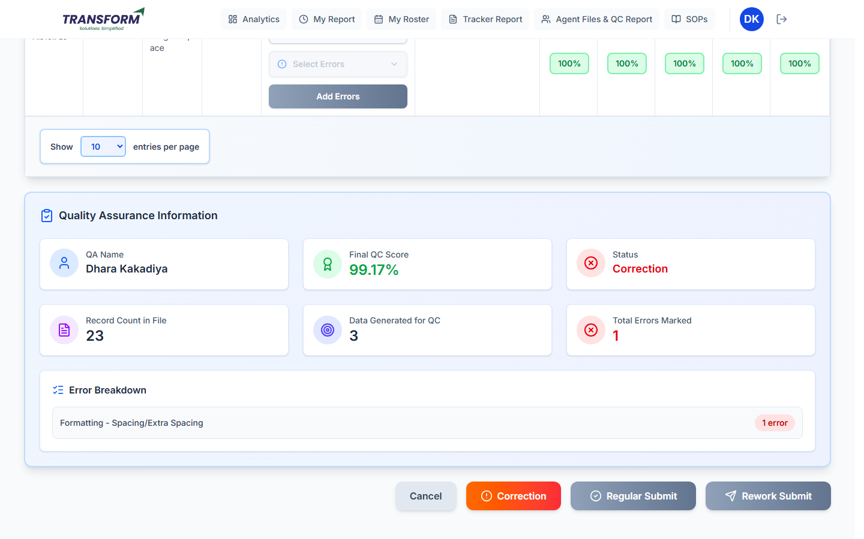
Figure 8: Summary and the submit buttons
7. Only the button that matches the score can be clicked: Regular Submit (100%), Correction (98% to 99.99%) or Rework Submit (below 98%). Cancel leaves the form without saving.
8. The Confirm QC Submission window shows the QA, agent email, project, task, status, score and error summary. Check them.
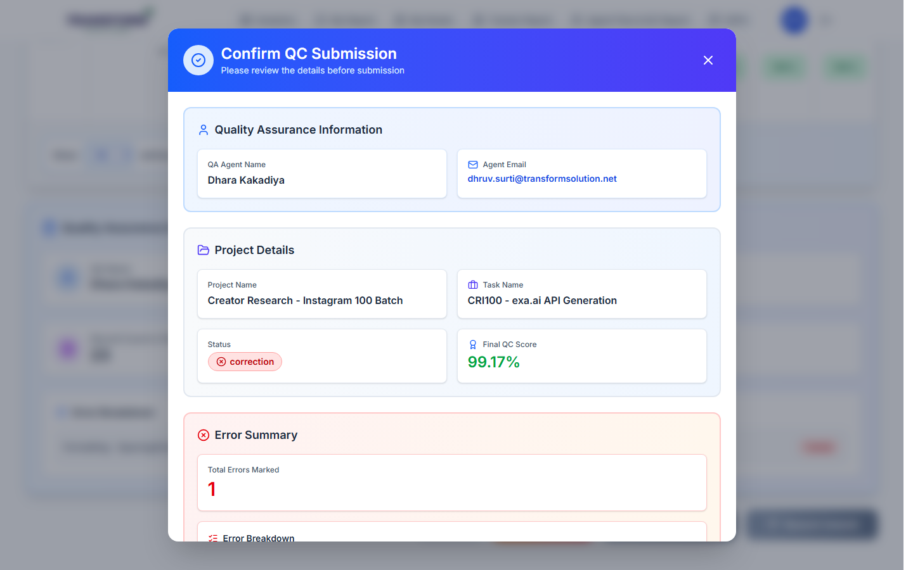
Figure 9: Confirm QC Submission
9. Type the Comments (required). Mention the QC Code and the error, for example 'QC Code 6417 - Formatting - Junk Character'. Click Confirm & Submit.
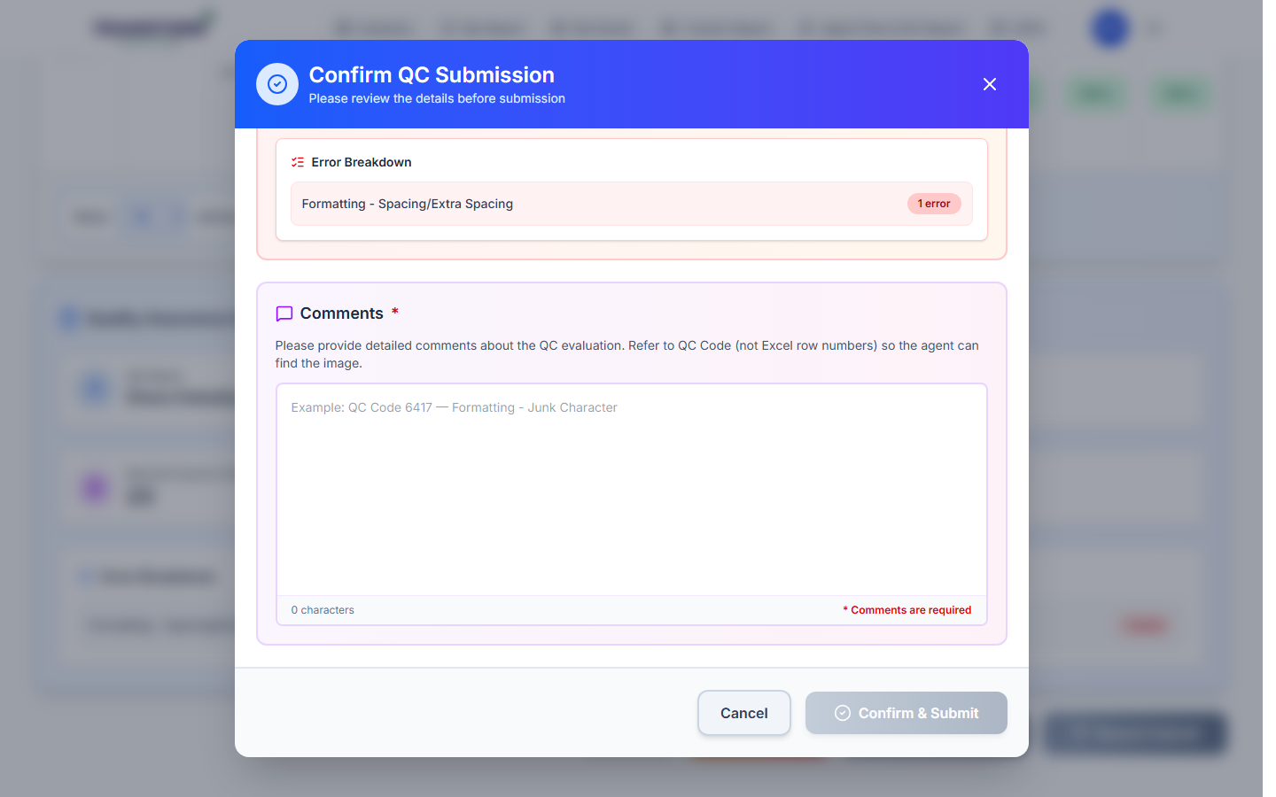
Figure 10: Comments are required before submitting
10. The file leaves your pending list. The agent is emailed the result and the marked QC file (error rows highlighted, errors in the last column) is saved for managers.

Worked score example
The project has four categories. Marking 'Spacing/Extra Spacing (-10)' on row 1 makes Formatting 90%. Row 1 = average of 90, 100, 100, 100 = 97.5% (shown as 98%). The file has 3 sample rows: (97.5 + 100 + 100) / 3 = 99.17%, so only Correction can be submitted.

6. Procedure - Correction and Rework cycle

6.1 What the agent does
1. The agent opens Analytics > Billable & QC Report > QC Report. Each file shows QC date, submission, project/task, score, Status (Regular / Correction #n / Rework #n), QC Status and Errors (View).
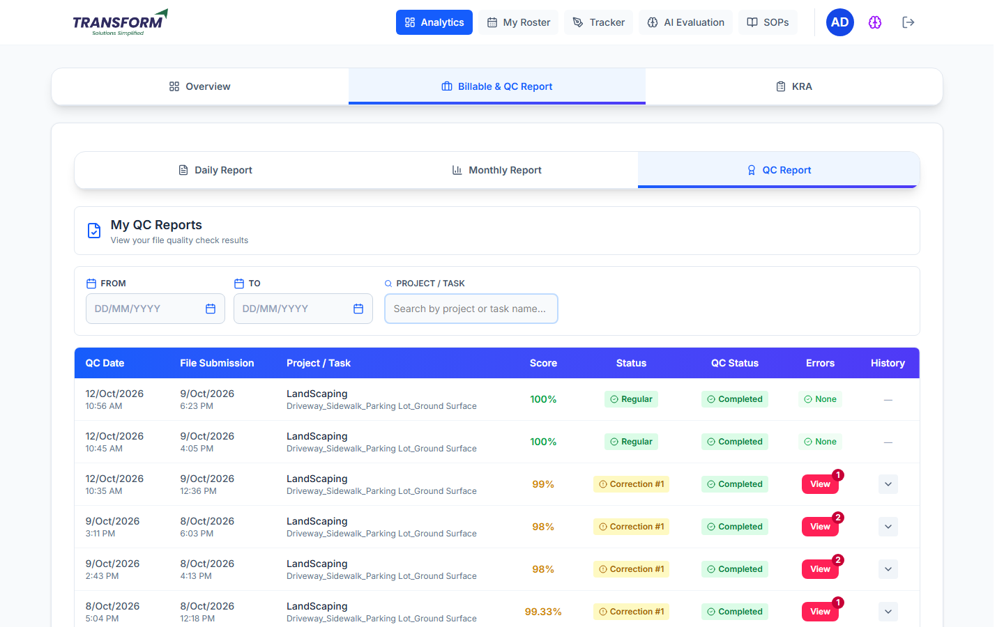
Figure 11: Agent - My QC Reports
2. The agent clicks the arrow in History to see every attempt, then Upload on the open attempt.
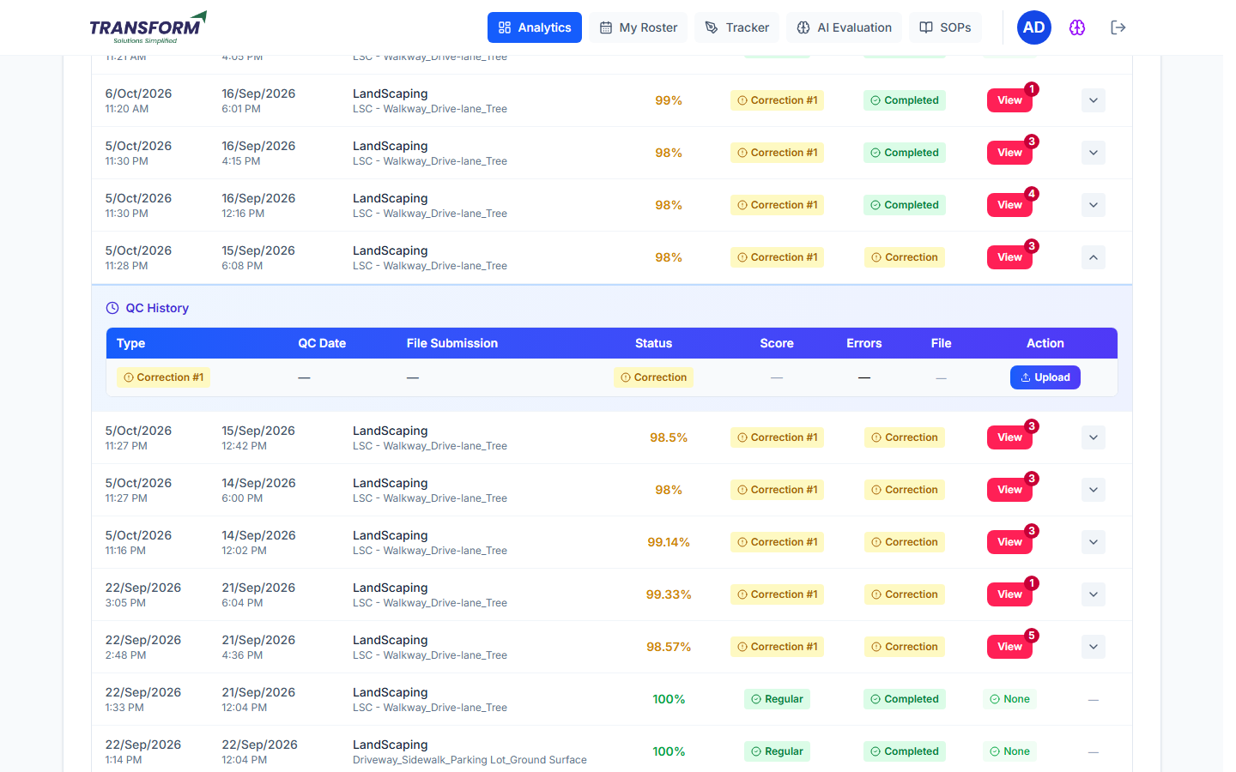
Figure 12: Agent - QC History with Upload on Correction #1
3. The agent selects the corrected / reworked Excel or CSV file and clicks Submit. The status becomes 'Under Review' until QA checks it.
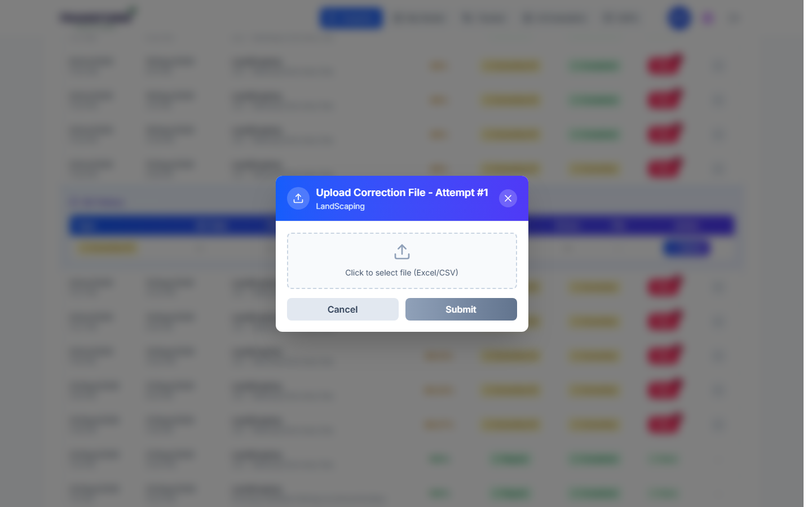
Figure 13: Agent - upload correction file

6.2 What QA does with the returned file
Open Agent's Rework & Correction File. The work date filter uses the original file date. Pick the task on the left.
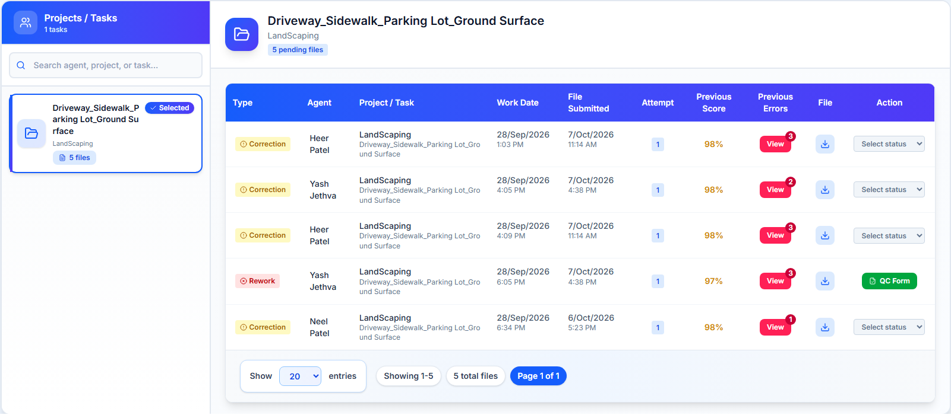
Figure 14: Returned files - Type, Attempt, Previous Score, Previous Errors, File, Action
- Type: Rework or Correction. Attempt: which cycle this is. Previous Score: the last QC score.
- Previous Errors > View lists the errors from the last check with their QC codes and points.
- File: download the file the agent uploaded.
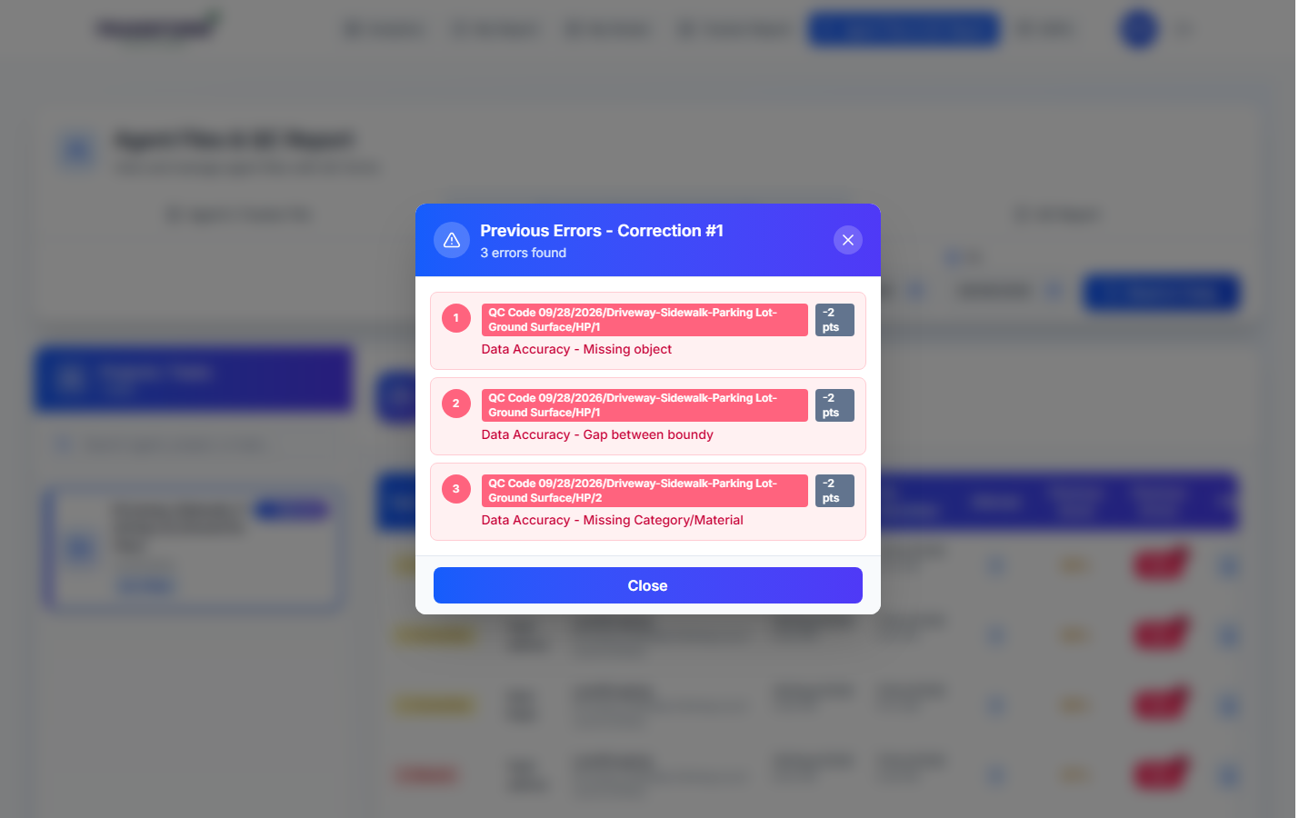
Figure 15: Previous errors for Correction #1
1. Rework file: click QC Form. A new sample is generated from the agent's latest uploaded file. Check it exactly like a new file and submit. Regular closes the file; Rework or Correction sends it back again (next attempt).
2. Correction file: download it and check the marked rows. In Action choose Completed (all fixed - file closed) or Correction (still wrong - goes back to the agent as the next attempt) and click Save Status.
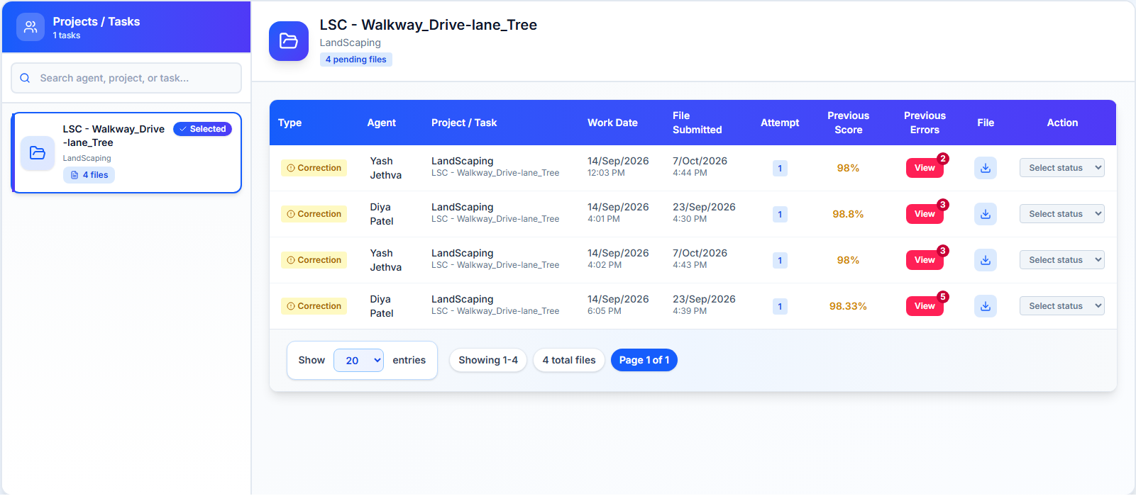
Figure 16: Correction files - choose Completed or Correction, then Save Status

6.3 Cycle summary
QA result | What happens next | Closes when
Regular (100%) | File is completed. | Immediately.
Correction (98-99.99%) | Agent corrects the marked sample and uploads it. QA sets Completed or Correction. | QA saves Completed.
Rework (below 98%) | Agent reworks the whole file and uploads it. QA fills a new QC form on it. | A rework check is submitted as Regular.

7. Procedure - Your QC Report
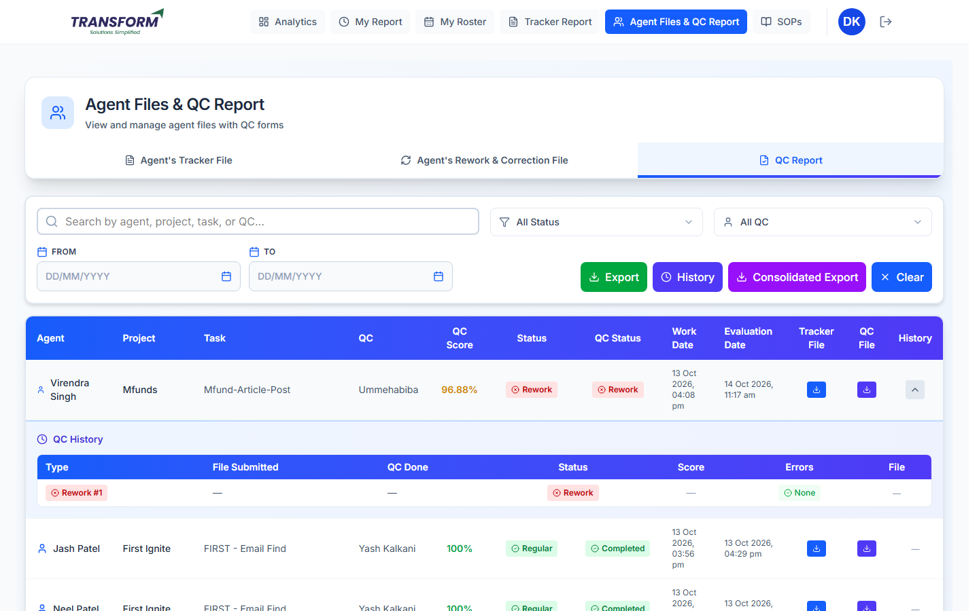
Figure 17: QC Report tab with a file's QC history opened
- Search by agent, project, task or QC; filter by Status, QC and dates. Clear resets the filters.
- Export downloads the table; History downloads the rework and correction cycles; Consolidated Export downloads the summary for the dates.
- Tracker File and QC File download the agent file and the marked QC file. The History arrow shows every attempt with its score and errors.

8. Rules to remember
- QC deadline: 24 working hours from submission (48 for night files added after midnight). Saturday, Sunday and holidays do not count.
- Scoring: every category starts at 100; each error takes off its points; a record's score is the average of its category scores; an error worth 100 points or more makes the record 0; the file score is the average of all rows on the form, including added rows.
- You cannot choose a different result than the score allows.
- Marks are not saved until Confirm & Submit. Refreshing or leaving the page loses them.
- Always write the QC Code in comments so the agent can find the row.
- If a QC was submitted by mistake, an admin can reset that tracker's QC (see the 'Reset QC for a Tracker' guide); do not fill it twice.

9. Common problems
Problem | What to do
'Every file record is already on the form' | All rows are already sampled or added; nothing to add.
No categories in Select Category | The project's category is not linked to an AFD. Ask admin.
QC Form keeps loading | Check the agent file opens with Click to Download. If not, ask the agent to re-upload the tracker file.
"Could not save QC" on submit | Do not refill repeatedly. Send the tracker number and a screenshot of the message (it shows the reason) to the HRMS team.
Agent cannot see Upload | The file is Under Review (already uploaded) or the attempt is closed.

